Domain modeling - CDS and cookbook and getting started
Ignore Java and Node js
Sql and join

{
"MY_CAP_PROJECT1_SYN_BOOKS":{}
// "MY_CAP_PROJECT2_SYN_AUTHORS":{}
}

{
"MY_CAP_PROJECT1_SYN_BOOKS":{
"target": {
"object": "MY_CAP_PROJECT1_BOOKS",
"schema.configure": "logical-cap_project1-grantor/schema"
}
}
//"MY_CAP_PROJECT2_SYN_AUTHORS":{
// "target": {
// "object": "MY_CAP_PROJECT1_AUTHORS",
// "schema.configure": "logical-cap_project1-grantor/schema"
// }
// }
}

{
"logical-cap_project1-grantor" :
{
"object_owner": {
"container-roles" :[
"cap_project1_access_g#"
]
},
"application_user": {
"container-roles" :[
"cap_project1_access"
]
}
}
}

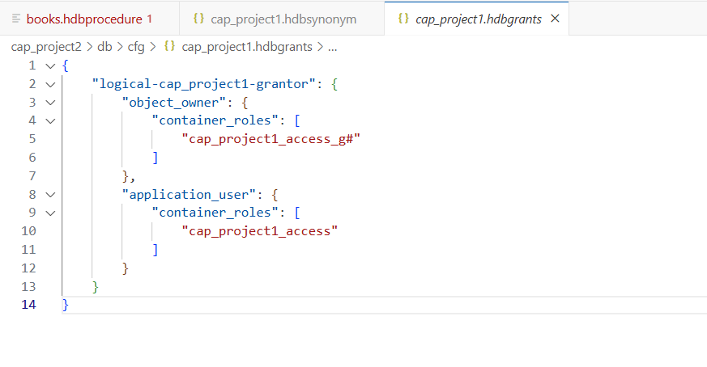

Undeploy part
Create package.json under db for the same

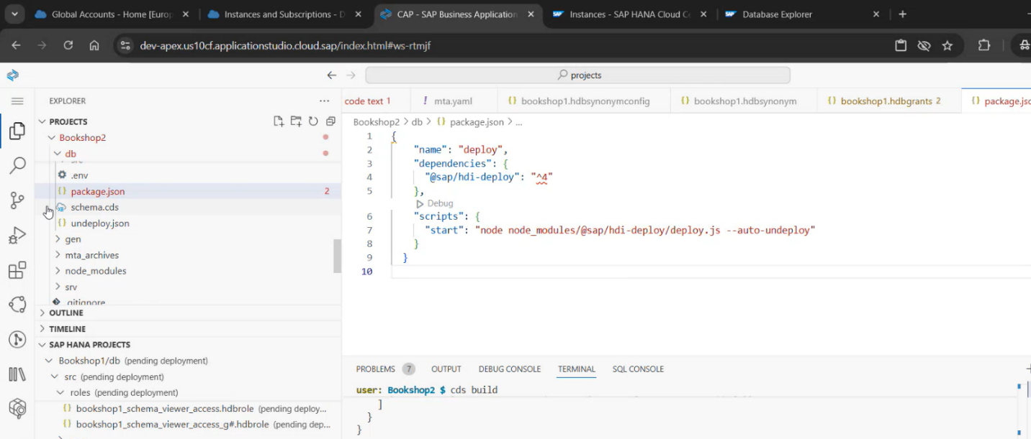

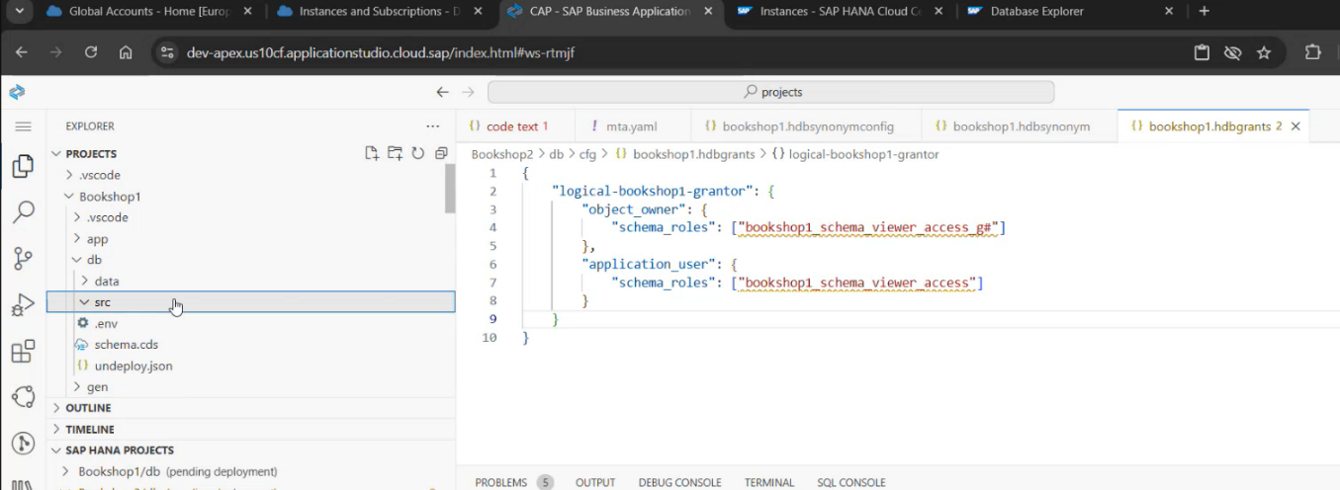

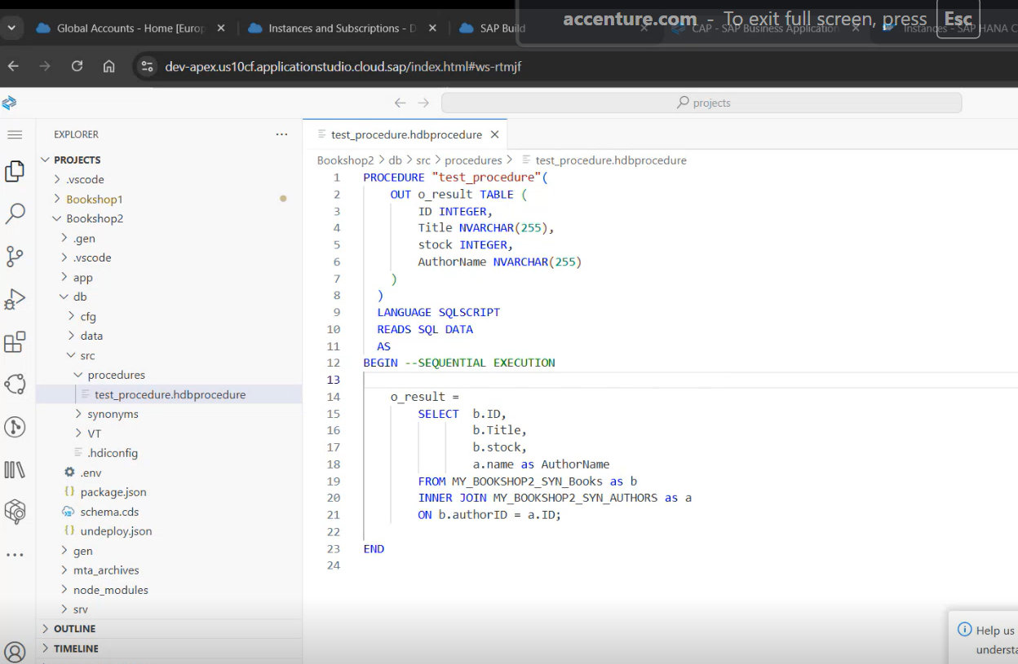

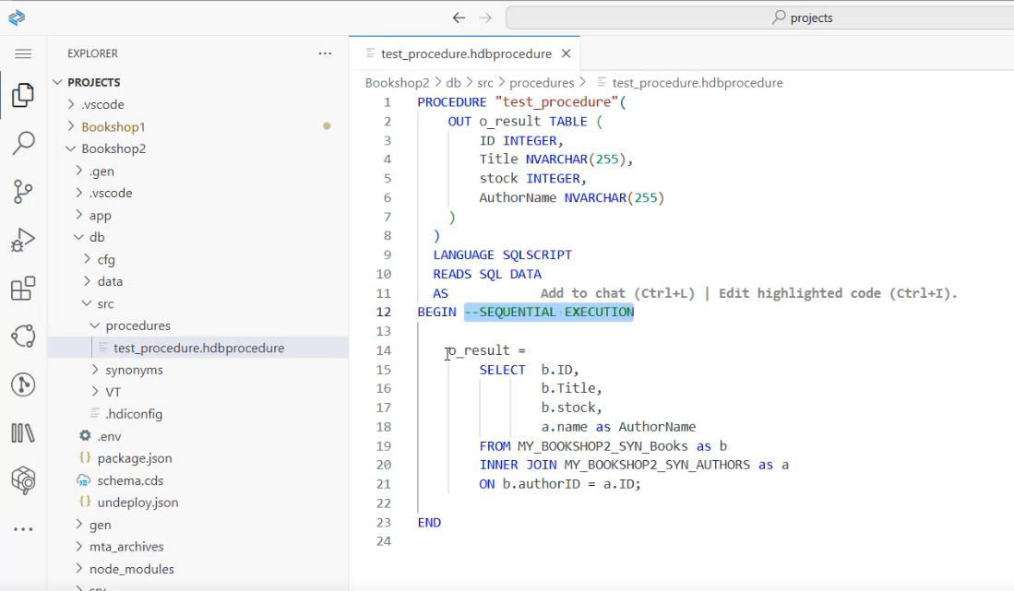

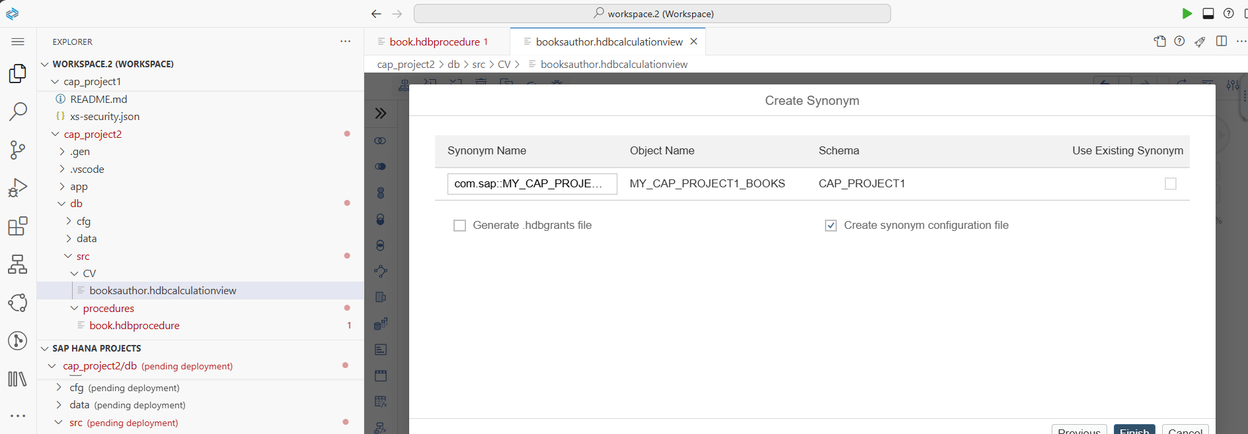

PROCEDURE "book"(
OUT o_result TABLE (
ID INTEGER,
title NVARCHAR(255),
stock INTEGER,
AuthorName NVARCHAR(255)
)
)
LANGUAGE SQLSCRIPT
READS SQL DATA
AS
BEGIN
o_reuslt =
SELECT a. ID,
a. title,
a. stock,
b. first_name as AuthorName
FROM MY_CAP_PROJECT2_SYN_BOOKS as a
INNER JOIN MY_CAP_PROJECT2_SYN_AUTHORS as b
ON a.ID = b.ID;
END

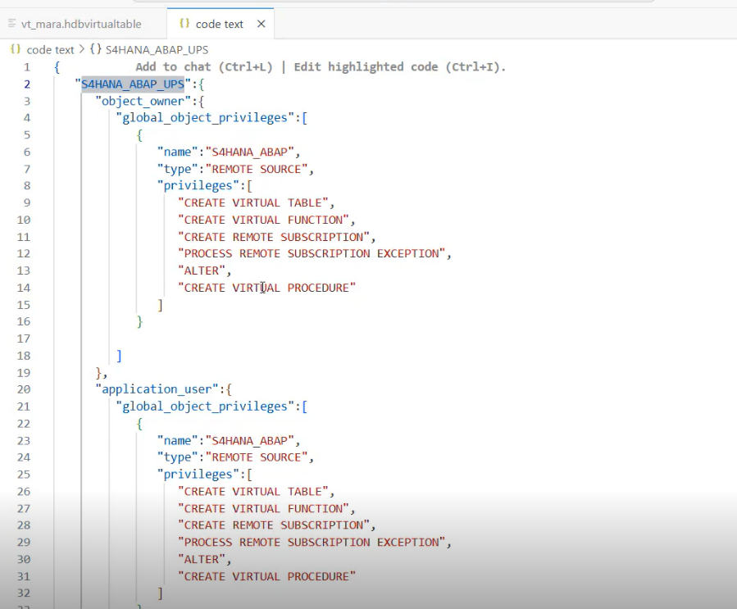

Replication
Flow graph
To be created in Native HANA Dev space

